Roll NO - 18

Srn no- 201700110

Name- Kunal Agarwal

Experiment No - 4

Aim -  Creating, deleting copying file/folder from local machine to HDFS system.

*******************************************************************************************************

Program :

Creating a directory in hadoop :

hdfs dfs -mkdir /folder_name

Copying file/folder from local machine  to hdfs:

hdfs dfs -put ~/Path_to_file_to_copy /Path_of_hdfs

Viewing file in hdfs:

hdfs dfs -cat /path_file

Contents of directory:

hdfs dfs -ls /dir_name

Deleting the file from hdfs:

hdfs dfs -rm -r /path_of_file_to_delete

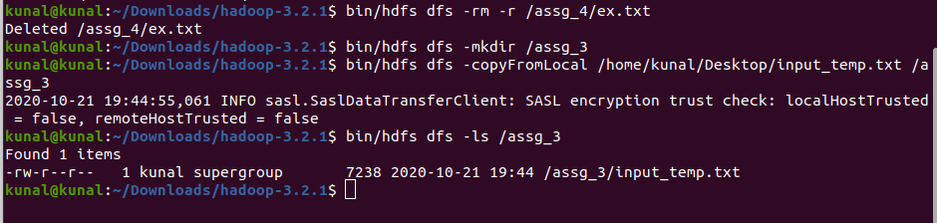Output

Conclusion: Successfully performed hdfs command (Copy,Delete,Create).